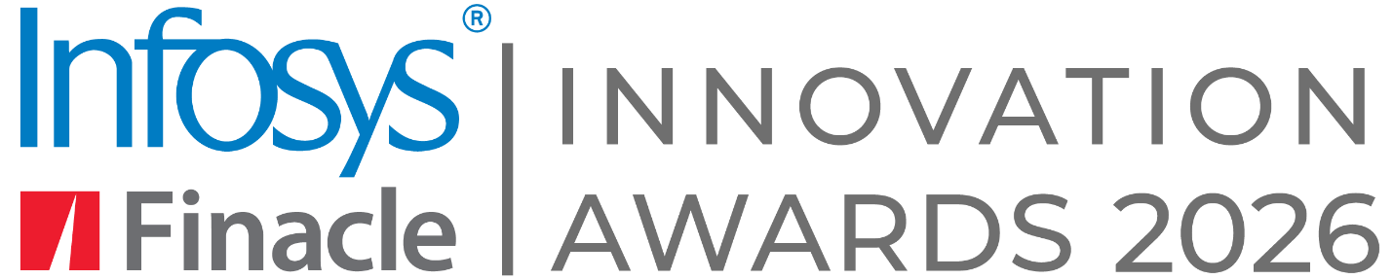

SUBMISSION FORM

- The nomination form once filled should be uploaded on the webpage
- Separate nomination forms to be filled for each submission
- All fields are mandatory, unless otherwise stated.
- Submission deadline – 15th January 2026
- Please share your filled nominations on these ids - FinacleAwards@infosys.com

Contact details
Salutation: | First name:
Last name: | Job Title:
Bank Name: (In case you win, this name will appear on the winning assets) | Bank Size: (Select Small to Mid-sized, Mid-sized to Large sized)
Email ID: | Country:
Phone 1: | Phone 2: (optional)
Marketing contact name: | Marketing contact email ID:
Bank address: (In case you win, we will send winning assets to this address)s

Submission Details
- Title of the Initiative:

- Select the category for which the initiative is nominated: Can choose to apply under multiple categories

☐ Break-through Sustainability in Banking ☐ Business Model Innovation
☐ Channel Innovation ☐ Corporate Banking Innovation
☐ Maximizing Customer Engagement ☐ Modern Technologies-led Innovation
☐ Process Innovation ☐ Product Innovation
☐ Transformation Excellence

- Summary of the submission:
Brief summary of the initiative: What was unique about the initiative? What impact did the initiative create - highlight the KPIs?

Project background and rationale: What is the business case for this initiative? What opportunities did you see in the market? What problems did you look to address? What were the desired outcomes?

Detailed description of the initiative: Explain the solution design and how this helped mitigate a challenge or resolve the problem. Explain why this initiative is innovative. What were the levers that were used to amplify impact, e.g. innovative use of new technology, innovative approaches etc.? How does this initiative help differentiate yourselves from your competition? How do you intend to build on the initiative’s success going forward?

Technology or implementation excellence: How complex was the project? What were the biggest challenges and how did you overcome those? What were the development practices (may include Agile Development, DevOps project management practices, Fintech startup collaborations, or usage of Cloud PaaS?)

How did you leverage Finacle for this initiative: What Finacle solutions did you use for this initiative? Explain how you leveraged the solution suite to drive the transformation and its outcomes

Delivery team, ecosystem partners and timeline: Internal team: size of the core team, key departments involved. External resources: technology vendors, professional services firms, Fintech partners, Project start, key milestones, go-live date

Quantifiable business benefits: Please share details about the business impact that can be numerically quantified. Viz. Increase in revenue or client numbers, productivity enhancement, cost, or risk reduction, etc.)

Qualitative Business benefits: Please share details about other business benefits (that are hard to quantify) such as improved user experience, reduced turnaround time, better products/ functionality, positive client feedback, social media buzz, etc.

Additional Information: Please provide any other relevant information which might help your nomination.

I consent for our bank to be recognized as a client of Infosys Finacle and authorize the usage of our logo

☒ Yes ☐ No

I consent that this nomination, if it wins, can be nominated for other leading industry awards by Infosys Finacle on our behalf by intimating us.

☒ Yes ☐ No

I consent to the data shared here for the creation of a case study to showcase our bank's award-winning innovation and these assets to be promoted on Infosys Finacle website and social media handles.

☒ Yes ☐ No

---------- End of the nomination submission form ----------
Please share your filled nominations on this id- FinacleAwards@infosys.com

